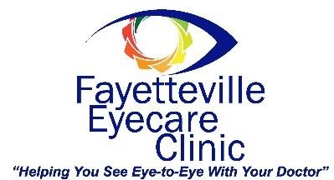

ABOUT YOUR INSURANCE
There are two types of health insurance that will help pay for your eye care services and products. You may have both and our practice accepts both:
- Vision care plans (such as VSP and EyeMed)

- Medical insurance (such as Blue Cross/Blue Shield, Medicare and Medicaid).

- Vision care plans only cover routine vision exams along with eyeglasses and contact lenses. Vision plans only cover a basic screening for eye disease. They do not cover diagnosis, management or treatment of eye diseases.
- Medical insurance must be used if you have any eye health problem or systemic health problem that has ocular complications. Your doctor will determine if these conditions apply to you, but some are determined by your case history.
- If you have both types of insurance plans it may be necessary for us to bill some services to one plan and other services to the other. We will use coordination of benefits to do this properly and to minimize your out-of-pocket expense.
- We will bill your insurance plan for services if we are a participating provider for that plan. We will try to obtain advanced authorization of your insurance benefits so we can tell you what is covered. If some fees are not paid by your plan, we will bill you for any unpaid deductibles, co-pays or non-covered services as allowed by the insurance contract.

I have read and agree with these policies.

_________________________________________ ______________________
Patient Signature (parent if child) Date
Please provide insurance cards to our staff member.

